After your app is on the PlasyStore or any other App Store, you might want to update. Maybe to correct mistakes in you’re app, or to add new features! To do that, you need to upload a new APK (for Android) to the PlayStore.

Level of difficulty:   
Estimated time: 5 mn

[**www.codapps.io**](http://www.codapps.io)by Clement Levallois **@codapps_io** [**www.coursera.org/learn/codapps**](http://www.coursera.org/learn/codapps)



**Module 4: Testing your app on a phone and distributing it**

*How to publish the updated version of an app*

Once you have uploaded the new APK file, all the users will receive a notification to update their apps (the same updates we receive to tell us that “a new version of the Facebook app is available!”)

BUT there is one thing to do before you upload the new APK file: you need to take its version number and change it with a higher number.

1. In NetBeans, right click on the name of your project and select “Properties”

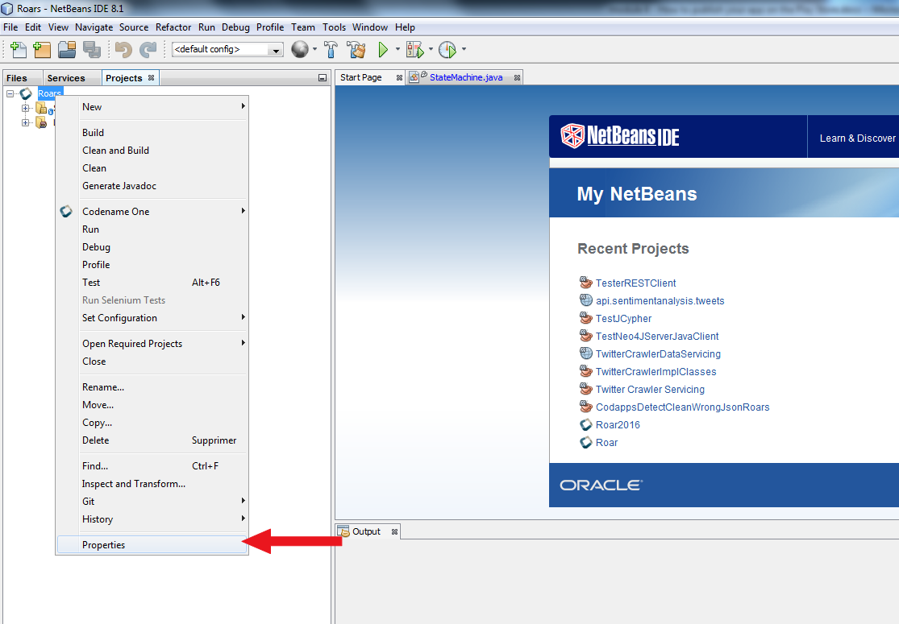

1. In the menu that opens, just change the version number which is 1.0 by default. Two ways:

Level of difficulty:   
Estimated time: 5 mn

* 1. Either you put 1.2, then 1.3 for the next version, then …., then 1.9, then 2.0…
  2. Or you can also put 1.0.1, 1.0.2, etc.

Basically, a widely used convention is that:

* For major upgrades, you increase the first digit (1.0 becomes 2.0)
* For minor upgrades, you increase the second digit (1.0 becomes 1.1)
* For minor bug fixes, you increase the last digit (1.0 becomes 1.0.1)

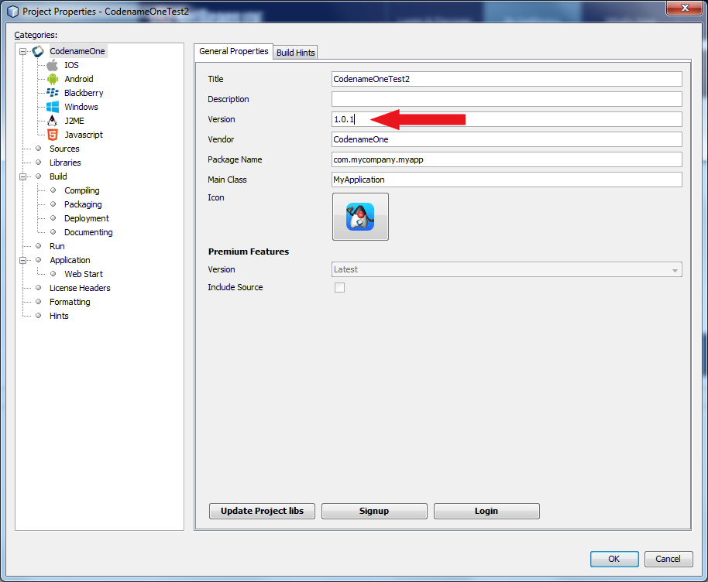

1. That’s it. You can send your Android build to Codename One, download the APK file, then upload it to your Google Developer account, and it will be available.

[**www.codapps.io**](http://www.codapps.io)by Clement Levallois **@codapps_io** [**www.coursera.org/learn/codapps**](http://www.coursera.org/learn/codapps)



**Module 4: Testing your app on a phone and distributing it**

*How to publish the updated version of an app*

**Module 4: Testing your app on a phone and distributing it**

*How to publish your app on Google’s Play Store*